**Dual Enrollment Frequently Asked Questions**

* **How do I find the class schedule for FSCJ?**

1. Go to [www.fscj.edu](http://www.fscj.edu)
2. Hover over “**Menu**” in the top left corner of the page
3. Click on **Academics**
4. Click on **Class Schedules**
5. On the right side of the page click on **Class Schedules** again
6. Choose the appropriate term (Fall begins in August- Spring begins in January)
7. Type in the first three letters of the class you want in subject box
8. Choose the appropriate campus (Nassau, North, or Online) and then click **search**.

* **How do I complete the student’s authorized term registration section of the dual enrollment application?**

After you find the course on the class schedule use that information to fill in the Course ID #, Class # and Course Title. The location of the class will be the name of the campus.

**Course ID Course Title**

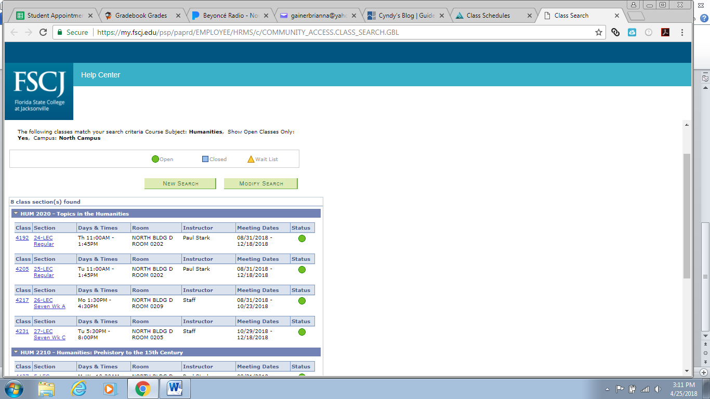

**Class Number Location (Campus)**

**Please pay attention to meeting dates and times because they may be different from the schedule at YHS. Also, please make sure your classes at FSCJ do not interfere with your on campus classes.

STUDENTS MAY NOT REGISTER FOR CLASSES ON THEIR OWN!!!! ALL COURSES MUST GO THROUGH MS. BENENHALEY.